Refocus The Brain Hub — Homepage Copy Rework
Draft copy for developer implementation. Structural notes are marked in grey callouts and are for reference only — final on-page copy is the plain text above each note.

1. Hero (video + intro)

Video:

Private ADHD and Autism assessments in Manchester and online nationwide

THE NORTH WEST'S FIRST PSYCHIATRY & NEUROSCIENCE BRAIN HUB

Specialist ADHD and autism assessments for children and adults, including complex, overlapping and previously misunderstood presentations. Consultant-led, with qEEG brain mapping and personalised care.

[BOOK A FREE 15-MINUTE CALL]

Under the video:

8 BILLION PEOPLE. 8 BILLION UNIQUE BRAINS.
Why are we still treating them the same?

Maybe the 8 billion people phrase can be on a navy background; I have an example below but don’t particularly like it

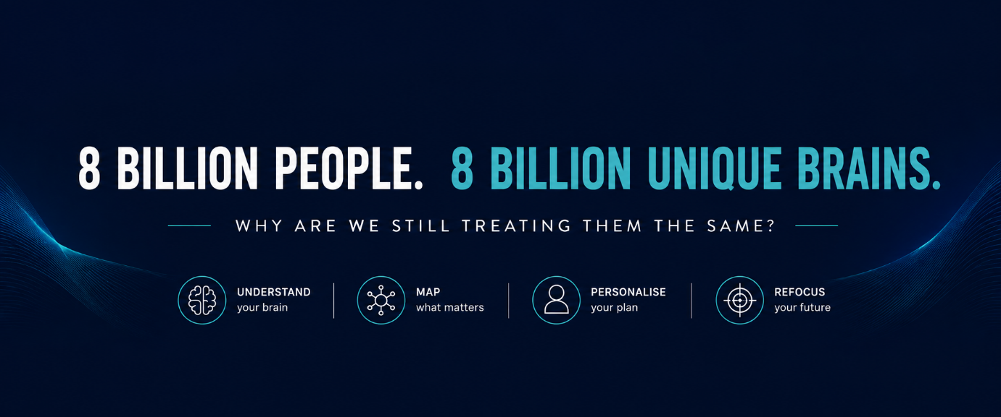

Based in Manchester, Refocus was built to move psychiatry forward, by bringing together specialist clinical assessments, brain mapping, neuromodulation and compassionate psychiatric care for modern, complex minds.

A questionnaire can't see your brain - we can.

We bring together consultant-led psychiatry and psychology, neurodevelopmental expertise, qEEG brain mapping, evidence-based traditional psychiatric treatment and neuromodulation support to build a more complete picture of how your brain works, and what may help it work better.

No one-size-fits-all pathways. No assumptions. Care built around your brain.

Precision brain care. Backed by science. Focused on you.

2. Why Refocus is different
(Replaces the three overlapping sections currently on the site: 'Why Refocus Exists', 'Why Refocus Is Different', 'Our Ethos'.)

A diagnosis can provide answers. But it should never be the end of the conversation.
ADHD, autism, anxiety, mood, hormones, sleep, trauma and cognitive difficulties overlap in complex ways — and the same symptoms can mean very different things in different people. That's why our assessments don't stop at a label. We look at development, mental health, cognition, lived experience and, where clinically useful, brain activity itself.

Second-opinion expertise
Our senior clinicians have spent decades leading NHS neurodevelopmental services — not just working in them. When a previous assessment hasn't given you the full picture, we have the depth to look again properly.

Neuroscience, not just questionnaires
Where clinically appropriate, qEEG brain mapping adds objective data on brain activity to the clinical picture — a layer most assessment services don't offer.

Care that continues beyond diagnosis
Understanding your brain is only useful if it changes what happens next. Our Brain Care pathway — neurofeedback, photobiomodulation, medication support, coaching — is built around what you actually need, not a fixed package.

Across the whole lifespan
From children struggling at school to women whose lifelong coping strategies stop working at perimenopause, we work with the full range of how brains present and change over time.

Note: 'Fast access / no waiting lists' has been deliberately dropped from this section — it undercuts the second-opinion/rigour positioning. If wanted for conversion, place it near booking/pricing instead.

3. How we can help (photo)
(Replaces the current flat 10-card grid — same services, now grouped under the three pillars above for visual consistency.) Ideally each service to click on and lead to the service page

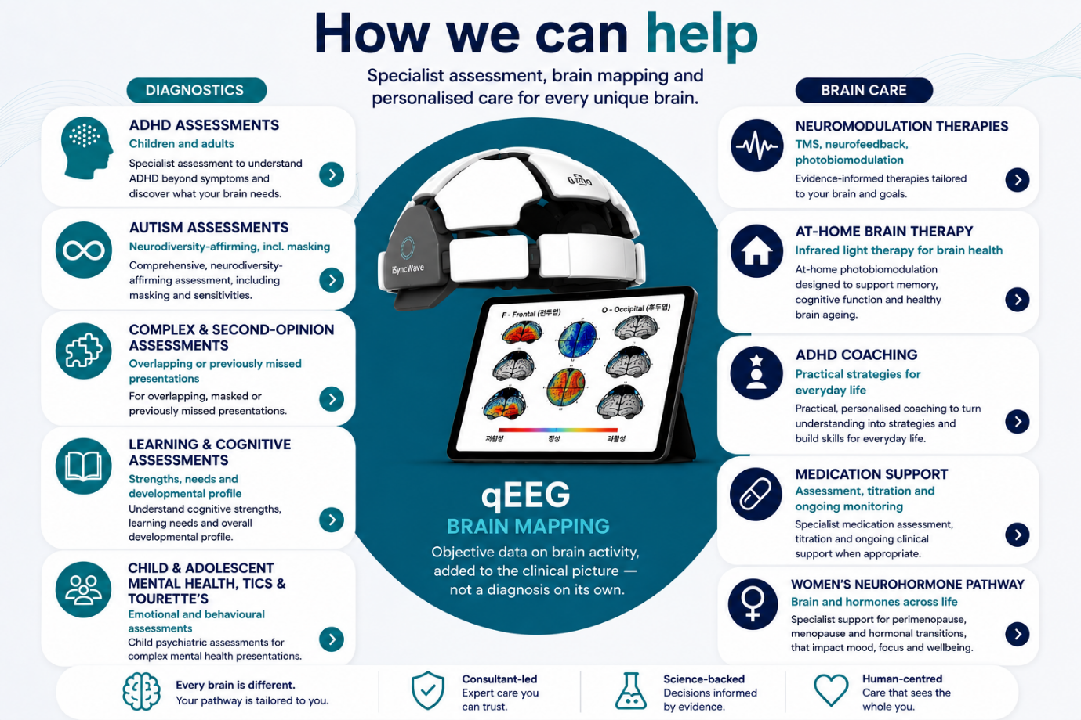

4. Consultant-led. Clinically robust.
Every assessment at Refocus is led by a Consultant Psychiatrist or Consultant Clinical Psychologist — not a junior clinician working from a protocol.
Our team has held senior leadership roles across NHS Trusts, including Neurodevelopmental Pathway Medical Lead, Trust Safeguarding Doctor, CAMHS Clinical Lead, Safeguarding Lead, and Expert Clinical Advisor to NHS England. Several of our clinicians trained at nationally recognised specialist centres, including a national second-opinion autism service.
That's not a marketing claim — it's the reason we can offer complex diagnostic assessment and second opinions with confidence, particularly where symptoms overlap, previous conclusions were unclear, or someone has spent years feeling misunderstood.
Assessments follow NICE guidance and recognised UK quality standards, using validated diagnostic tools (for ADHD: DIVA-5, Young DIVA-5, for autism: ADOS-2, ADI-R), developmental and collateral history, and senior clinical judgement — not questionnaire scores alone.
Our written reports are built for real use: shareable with GPs, schools, universities and other professionals involved in your care.

5. Understand. Map. Personalise. Refocus.

Understand
Start with the whole person. We listen to your story, development, strengths and difficulties before deciding what they mean. From ADHD, autism and learning differences to children's mental health, complex neurodevelopmental presentations, and tics and Tourette's — our assessments are built to tell apart presentations that look similar on the surface but aren't.

Map
See another layer of the picture. Where clinically appropriate, we add qEEG brain mapping — a non-invasive recording of the brain's electrical activity. It doesn't replace clinical assessment and isn't used to diagnose ADHD, autism or any other condition on its own. It gives us an additional, objective source of information on patterns of brain activity, alongside the clinical picture.
Because sometimes the first step isn't another label. It's a clearer picture.

Personalise
Use what we learn to guide what comes next. Two people can share the same diagnosis and experience it completely differently — your recommendations should reflect that. We combine clinical expertise, your individual circumstances and, where relevant, neuroscience data to build a plan that may include psychoeducation, ADHD coaching, medication support, neuromodulation approaches like TMS – trans magnetic stimulation, neurofeedback or transcranial photobiomodulation.
The right pathway is the one that makes sense for you.

Refocus
Move forward with greater clarity. Our goal isn't simply diagnosis or treatment — it's helping you understand your brain well enough to make better decisions about what happens next, at school, at work, at home, and through different stages of life.

The section below to be integrated where now we have Who do we support; keep same colours and format just the wording are slightly different below:

6. Built for complex minds
We support children, teenagers and adults across the lifespan — particularly people who have spent years thinking “why is everything harder for me than it seems to be for everyone else?”
• The bright child who holds everything together at school — and falls apart at home.
• The teenager whose ADHD, autism, anxiety and emotional regulation difficulties overlap.
• The adult who has spent decades compensating — without ever fully understanding why life feels harder than it should.
• The woman who reaches her forties and finds that the strategies that worked all her life suddenly no longer work.
• The person whose difficulties don't fit neatly into one diagnostic box — and needs someone to look at the whole picture.
• The person who already has a diagnosis — but still doesn't feel they truly understand their brain.
• The high performer who isn't struggling — but wants to understand their brain, optimise cognitive performance and explore neuroscience-led ways to go further.

7. A message from our founder
Dr Miriana Vrajitoriu
Consultant Child & Adolescent Psychiatrist | Founder & Medical Director
I spent over two decades in psychiatry, including years leading NHS neurodevelopmental services. I helped assess complex children and young people, develop ADHD and autism pathways, and support families searching for answers.
And yet one question stayed with me: why, when every brain is different, does mental healthcare so often begin by assuming the same pathway will work for everyone?
Refocus grew from the belief that psychiatry and neuroscience shouldn't sit in separate worlds. We can listen to someone's story and apply rigorous clinical assessment. We can also use modern neuroscience to understand another layer of brain function. Bringing those together is what makes care genuinely individual.
Refocus is the service I wanted to see exist — clinically rigorous enough for complex cases, curious enough to look beyond the obvious, and human enough never to forget the person behind the data.
There are 8 billion brains in the world. Your care should begin with understanding yours.
Note: The longer personal story (perimenopause/burnout journey) currently on the live homepage is strong and should stay — but we can move it to the About page, to keep the homepage's pace moving toward booking.

At the end the phrase

Ready to Refocus?
Get started today?
Change to:

READY TO REFOCUS?
Start With Understanding Your Brain.

Then instead of an email-only field, maybe two clear actions:

BOOK A CONSULTATION | EXPLORE OUR SERVICES

